East Side Mario’s (Gateway Location) Facebook Engagement Hacks and Tips to Increase Sales

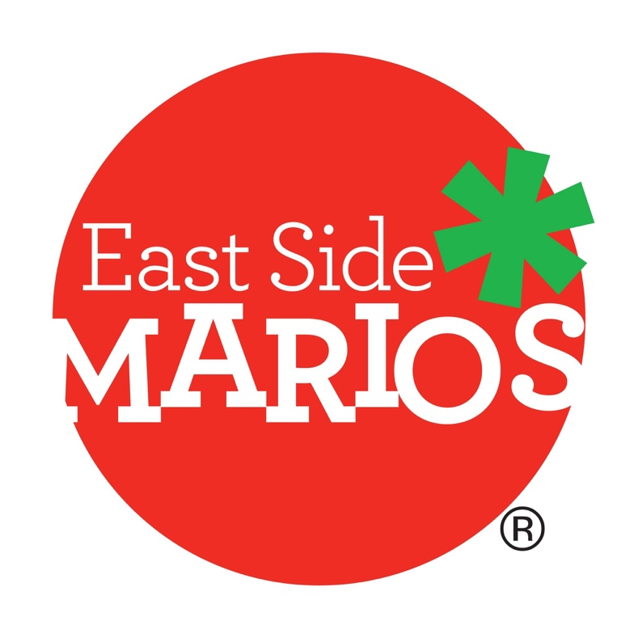

**Audience Overview**

Likes: 25

Ratings: 2.7

Posting habits: 0.46 times a day

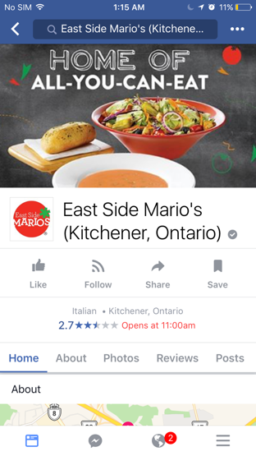**Facebook analysis and Engagement hacks.**

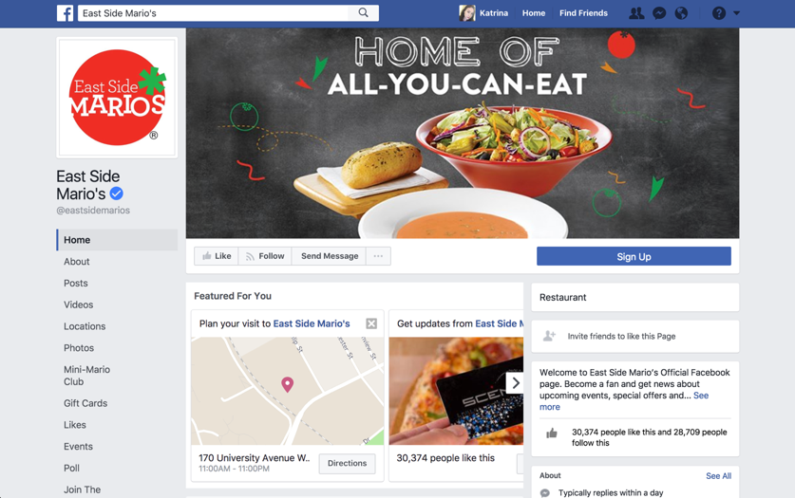

Observations:

* Cover art and profile photo are properly positioned in mobile and desktop.
* Post frequency is low (about 0.46/day)
* Facebook page is depersonalized. Posts are the same on other East Side Mario’s FB pages.
* Looks like you are not boosting some posts to get more likes and awareness – this limits how effective you can be with your targeted advertising campaigns.
* No sign of advertising campaigns.
* East Side Mario’s Kitchener Page has only 25 likes (although East Side Mario’s official verified page has 30,373). It’s really low.
* Ratings is at a low of 2.7 out of 5. When people arrive to the Facebook page this is one of the first things that Facebook shows them (especially on the mobile view and most people browse on their phones)!

Recommendations:

* Post minimum of 1 time per day. Ideally at least 5 times a week. Don’t forget weekends, the most engagement happens on the weekends, particularly Saturdays.
* If you consider boosting posts to gain more exposure, don’t simply hit the “boost” button – make sure to use FB ad manager to manage your ads, and we recommend advanced targeting campaigns so you don’t waste your advertising dollars (see section on advertising on Facebook).
* Run a campaign to boost positive reviews on Facebook. For example, offer select tables free desert to everyone who leaves a review on the page.

**Engagement hacks to understand**

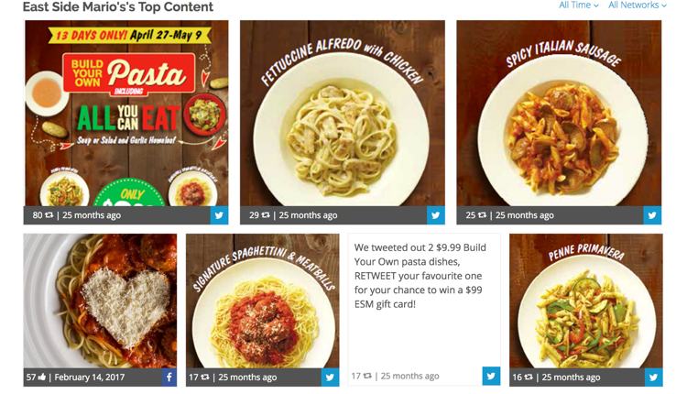Posting the right photos and videos with the right captions is crucial for building a “likeable” online presence. You can win more customers through social media if you keep them interested. Here are 2 rules to think about when engaging with people online (VRIN Score & RBSCPC).

*7 posts customers engaged with the most on Twitter and Facebook.

VRIN score

* Valuable – what is the value? Are people going to be excited to share this?
* Rare – how rare is it?
* Inimitable – how easy can that skill or post be copied and used by a competitor?
* Non-substitutable – how easy is it to substitute?

RBSCPC rule

* Rare – as described above
* Branding – typically posts/photos that showcase the brand. It can be a photo of a chef or an outside shot of the restaurant. This type of post fan be used as a litmus test to test the likability of your brand/restaurant to your customers.
* Solidarity Posts – these are posts that glorify the community at large and give people a sense of solidarity or togetherness. For example, a chart of farms in Ontario that supply food for the restaurant.
* Clarity – posts need to be clear. Don’t put too much details or text in your photo.
* Picturesque – photos need to be well shot. But not too professional-looking, especially on Instagram.
* Customer cravings – look at what people say the like and post the things that they crave. Photos with more cheese on the food seem to perform better than other ones.

**Facebook Marketing Techniques**

Facebook ads should be targeted to the right people, in the right locations and preferably in the right age range to save advertising dollars and improve the relevance of your ad.

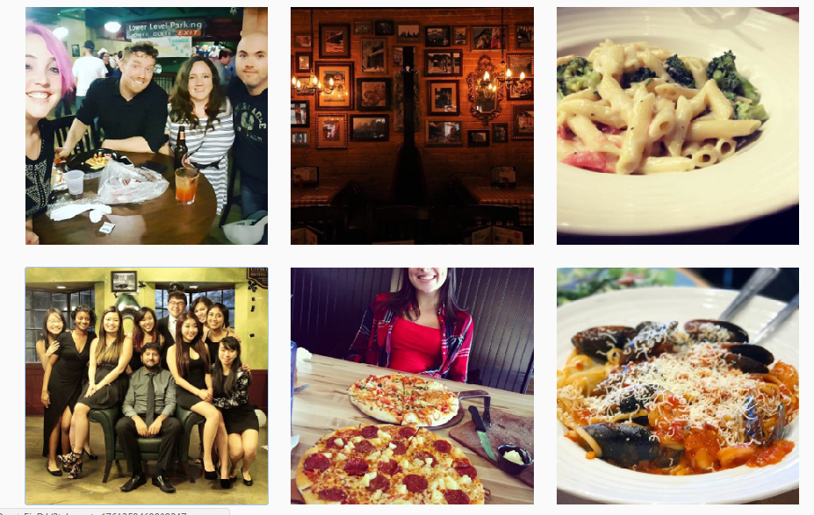

*Instagram photos of customers who geo-tagged East Side Mario’s.

**What are your goals with Facebook?**

* It’s not just a posting tool, it’s also a business tool.
* Attract new customers and generate sales
* Develop a competitive advantage on social media over your competitors who haven’t figured it out yet

Recommendations:

* Post content that leverages the brand’s likability and status with tactics described in the previous section.
* Boost posts 4-5 times a week with advanced targeting
* Promote offers online with advanced targeting and the right call to action that customers can follow
* Track the number of customers who claim online offers at the restaurant.